Creating Shortcuts

As we move clients from the Q:drive to the V:drive, we want to ensure client folders remain in the Q:drive as our source of truth. To do this, we will move (cut/paste) client documents from Q to V and create a shortcut in the Q drive to direct anyone searching to the V drive. See below.

Start by opening both network folders (V: and Q:).

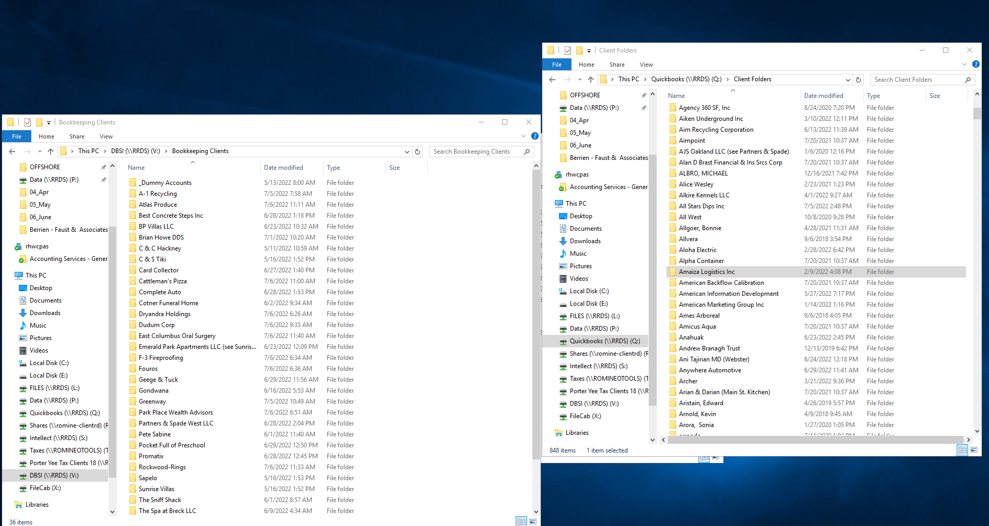

In the V: drive, create a folder for the client. In the example below, this will be for Amaiza Logistics. In the Q:drive, select all the files in the folder (or ctrl + a), right click and select cut. Go to the client folder in the V:drive and right click and select paste. If a dialog box pops up, choose “replace files in destination.”

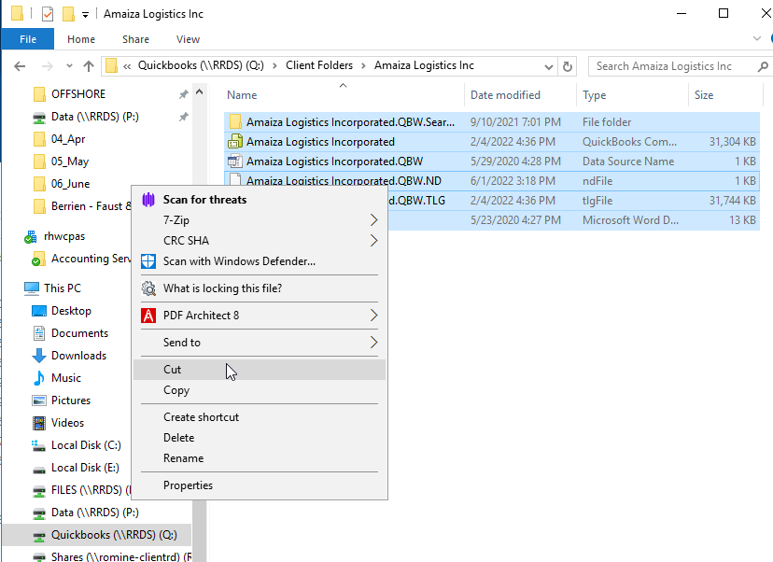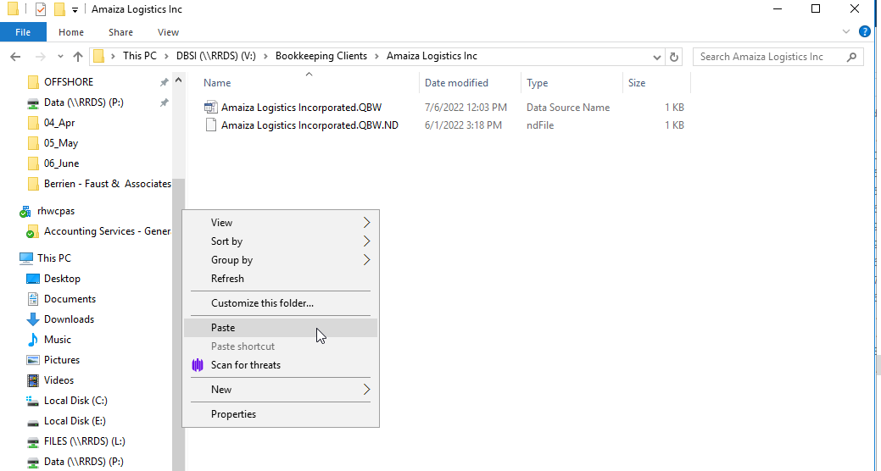

This will move all files from the Q drive to the V drive. Now we need to create a shortcut in the Q drive to the V drive. In the V: drive, go back one page. Right click and drag your client folder from the V: drive to the Q: drive within the client folder. Release your right click and choose “Create shortcuts here.” This will create a shortcut for anyone looking in the Q drive for a client and redirect them to the V drive.

